SEND COMMANDS TO ASHTECH RECEIVER

Here under, user will find short explanation on how to send commands to PM100/PM200/PM800/PF800 and how to record the responses from the receiver.
Some commands will induce long response from receiver and it may be not convenient just to display the response. So user must record these responses in a TXT file to allow it to be viewed later.

In the following example, we will use software called AshCom which is a tool available on our FTP site here:
ftp://ftp.ashtech.com/Utility Software/AshCom/V3.00.38/ashcom-v338.zip

Any other communication software can be used (hyperterminal, WinCom, …)
In the case of WinXP, Hyperterminal is part of the package. In Win7, this software is not anymore provided. So user must use other communication software.

Open AshCom
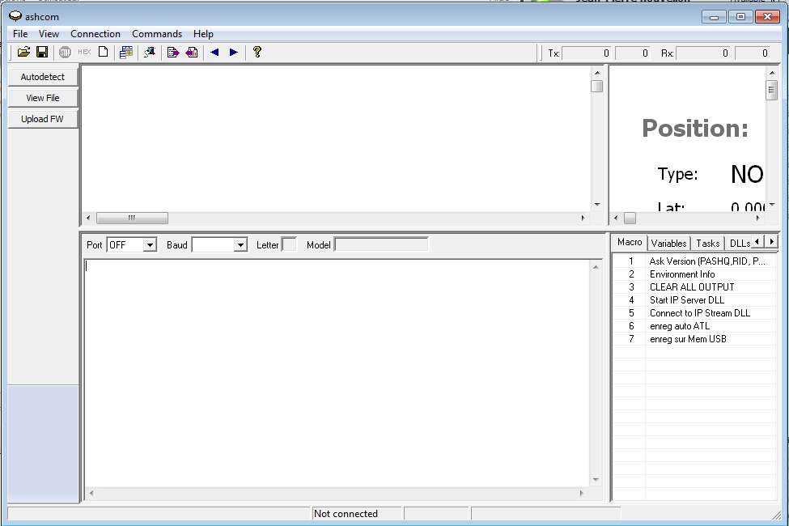
Select the right PC COM port and the correct speed.
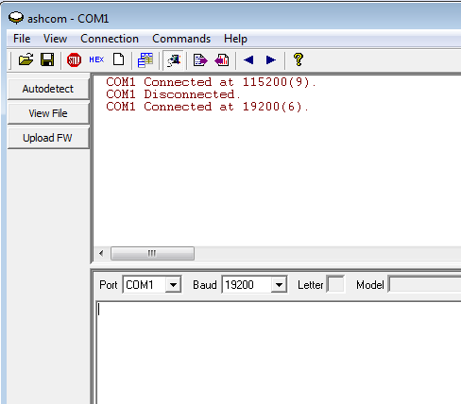
Ashtech receivers works at 19200 bauds by default.

Select directory where you want to record the TXT file containing the responses to the commands; click on the icon
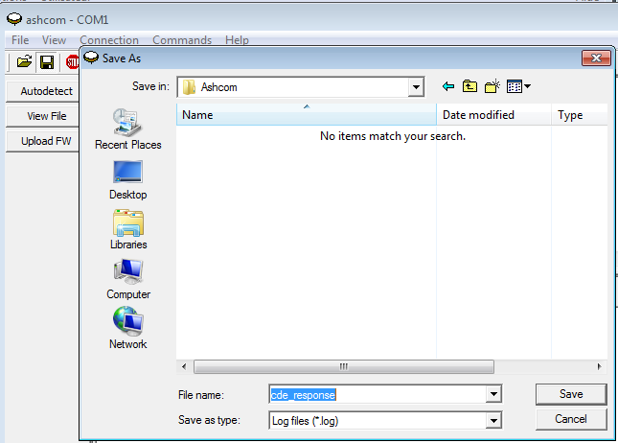
Enter the file name. By default extension will be LOG but you can change it to TXT if you want.
As soon as you click on SAVE button the record starts. The icon will be highlighted

Send commands
Commands must be enter in the lower part of the screen.
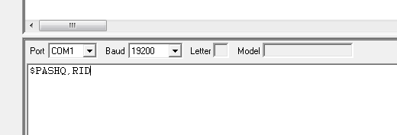
When you push Enter key, AshCom will send the command to the receiver.
Response will be seen on the upper side of the screen:
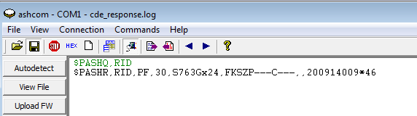
In green is the recall of the command sent and in black is the response of the receiver

To stop the record, just click on the icon. The icon will not be anylore highlighted and the record will stop.

The commands generally asked from Tech Support are :
$PASHQ,RID
$PASHQ,OPTION
$PASHQ,VERSION
$PASHQ,PAR (this command need to be recorded as the response too long to be displayed)

Recording a Configuration setup file (PM800/PF800)
User has now the possibility to record all configuration setup in a file. He will then be able to configure others receivers with the same configuration using that file.
To save the configuration, user must connect a USB memory key to PM800/PF800
Then he will have to send the command: $PASHS,PAR,SAV,2

When checking the USB key on Windows Explorer, user will find a file named like this
PF_sssss_dddhhmmss.par where
PF means ProFlex800 (PM in the case of ProMark800)
sssss means last 5 digits from serial number
ddd means Julian day of the year
hh means hours
mm means minutes
ss means secondes
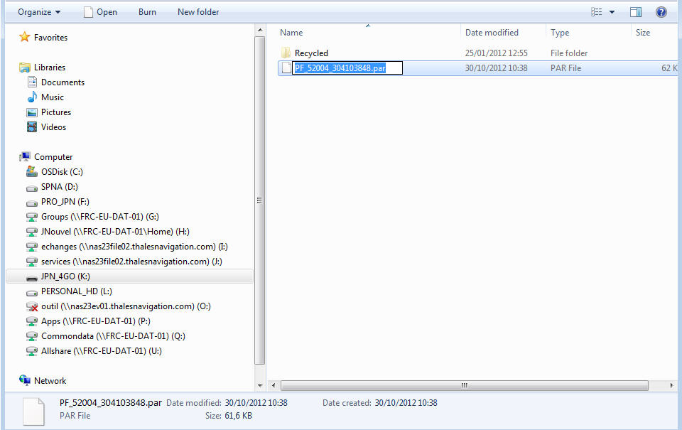
This file can then be introduced into another receiver:
Connect USB key containing the PAR file to the receiver
Send the command $PASHS,PAR,LOD,2,file_name.PAR
And receiver will get the same configuration as the first one.

